**EXPERIMENT NO. 2**

|  |
| --- |
| **Student Name and Roll Number: Avtar Singh - 20csu241** |
| **Semester /Section:5th / FSB** |
| **Link to Code:** |
| **Date:10/08/2022** |
| **Faculty Signature:** |
| **Marks:** |

|  |
| --- |
| **Objective:**  To write the shell programming code for the following. |
| **Outcome:**  Student is able to write code in shell programming |
| **Problem Statement:**  a) Write A Shell Program of Hello World  b) Write a shell program to find factorial of a number.  c) Write a shell program to find gross salary of an employee.  d) Write a shell program to display the menu and execute instructions accordingly  **(i)**List of files **(ii)**Process Status **(iii)** Date **(iv)** users in program **(v)** Quit |
| **Background Study:**  A shell script is a file with a set of commands in it. The shell reads this file and executes the instructions as if they were input directly on the command line.  A shell is a command-line interpreter and operations such as file manipulation, program execution and text printing is performed by shell script. So, we will use vi editor to edit our files. |
| **Question Bank:**   1. What is a shell?   Ans. The shell is **the layer of programming that understands and executes the commands a user enters**.   1. What is the significance of $#?   Ans.$# **shows the count of the arguments passed to the script**   1. What are the different types of commonly used shells on a typical Linux system?  * Ans.The Bourne Shell (sh) * The GNU Bourne-Again Shell (bash) * The C Shell (csh) * The Korn Shell (ksh) * The Z Shell (zsh)  1. How will you pass and access arguments to a script in Linux?   Ans.Arguments can be passed to the script when it is executed, **by writing them as a space-delimited list following the script file name**. Inside the script, the $1 variable references the first argument in the command line, $2 the second argument and so forth. The variable $0 references to the current script.   1. Use sed command to replace the content of the file (emulate tac command)   **sed -i 's/old-text/new-text/g' input.txt** |

**Student Work Area**

**Algorithm/Flowchart/Code/Sample Outputs**

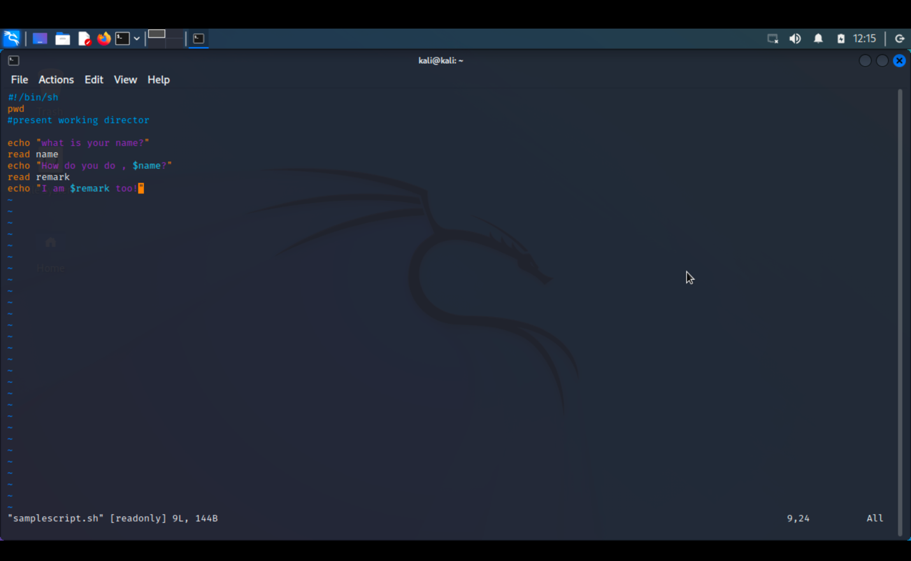

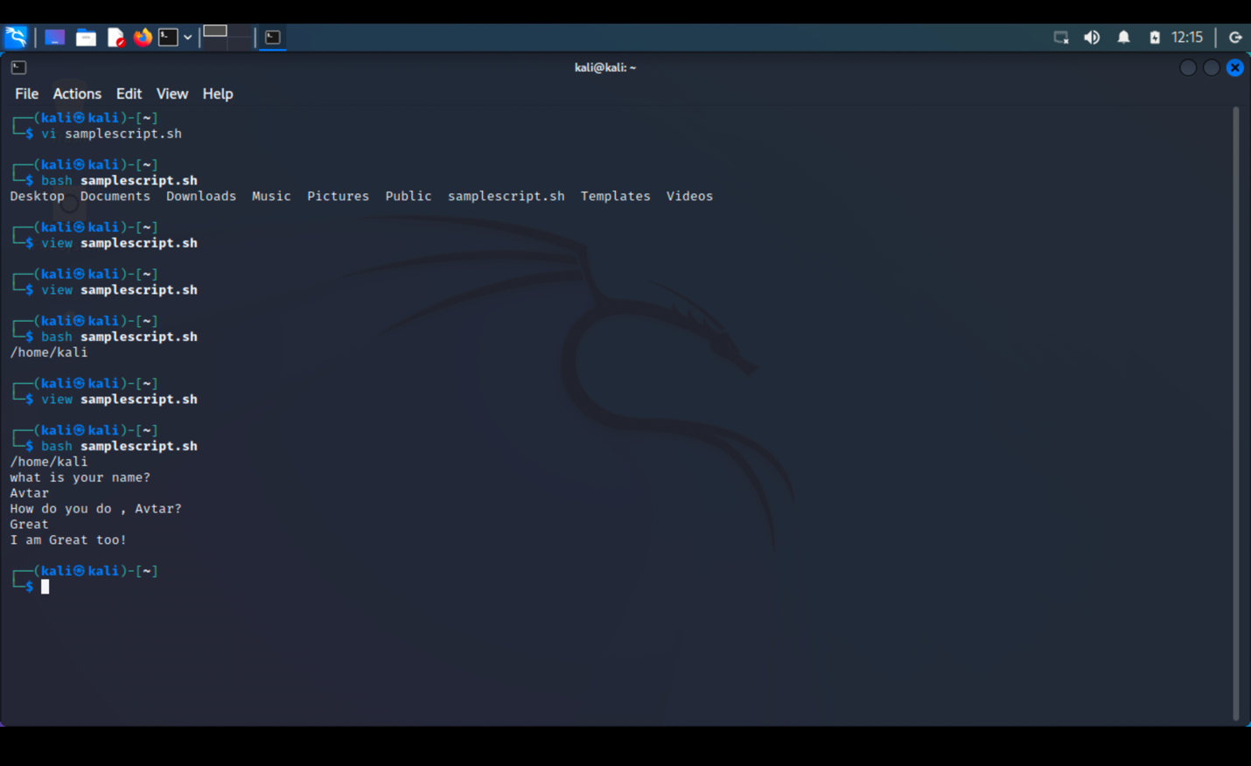

a) Write A Shell Program of Hello World

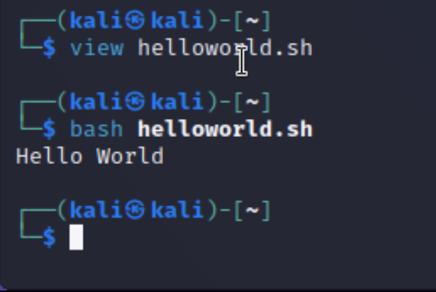

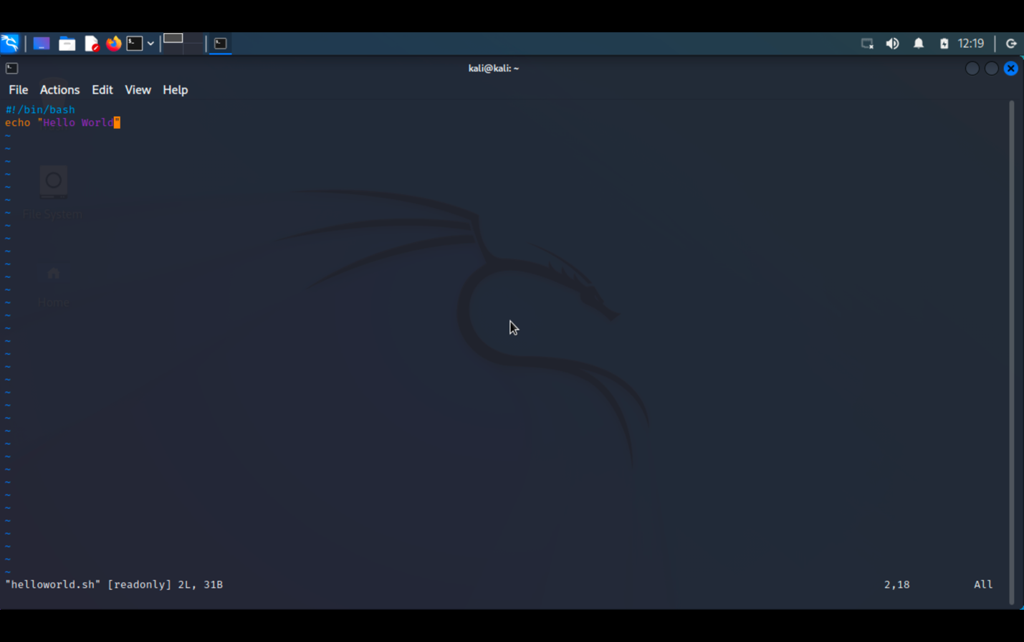

b) Write a shell program to find factorial of a number.

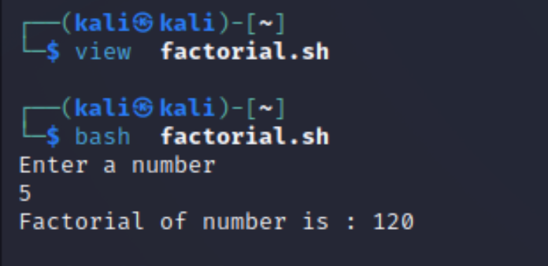

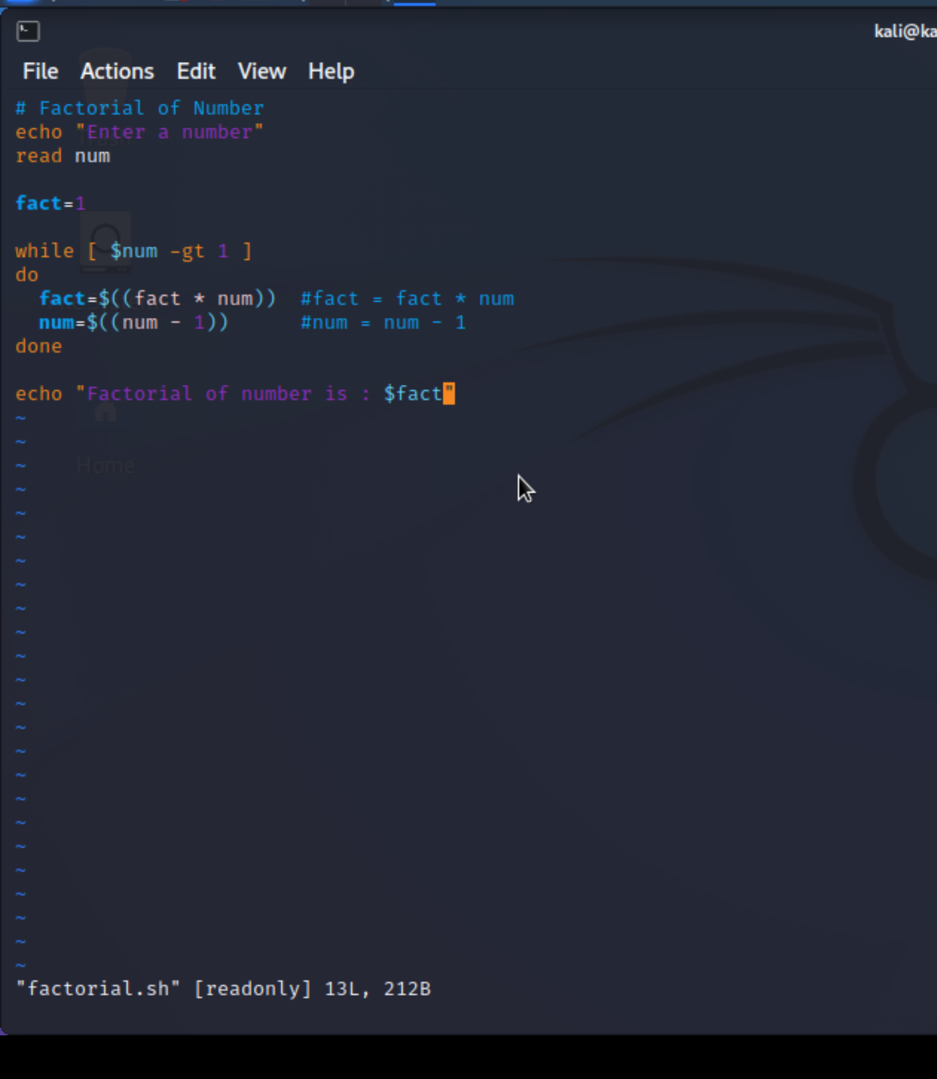

c) Write a shell program to find gross salary of an employee.

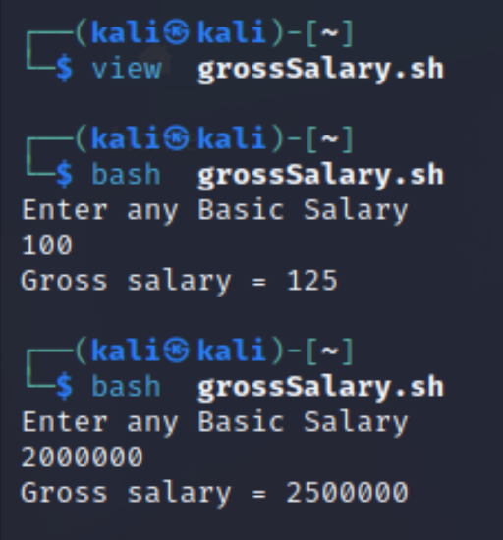

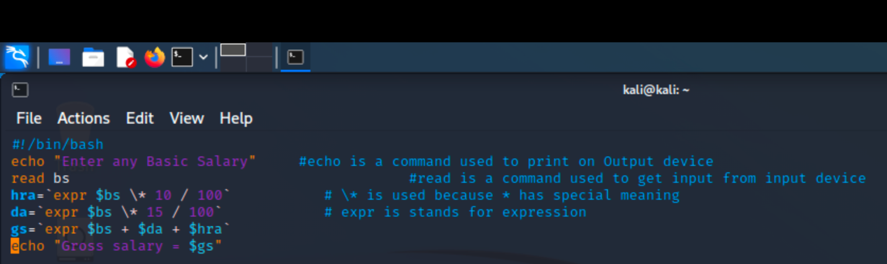

d) Write a shell program to display the menu and execute instructions accordingly

**(i)**List of files **(ii)**Process Status **(iii)** Date **(iv)** users in program **(v)** Quit



